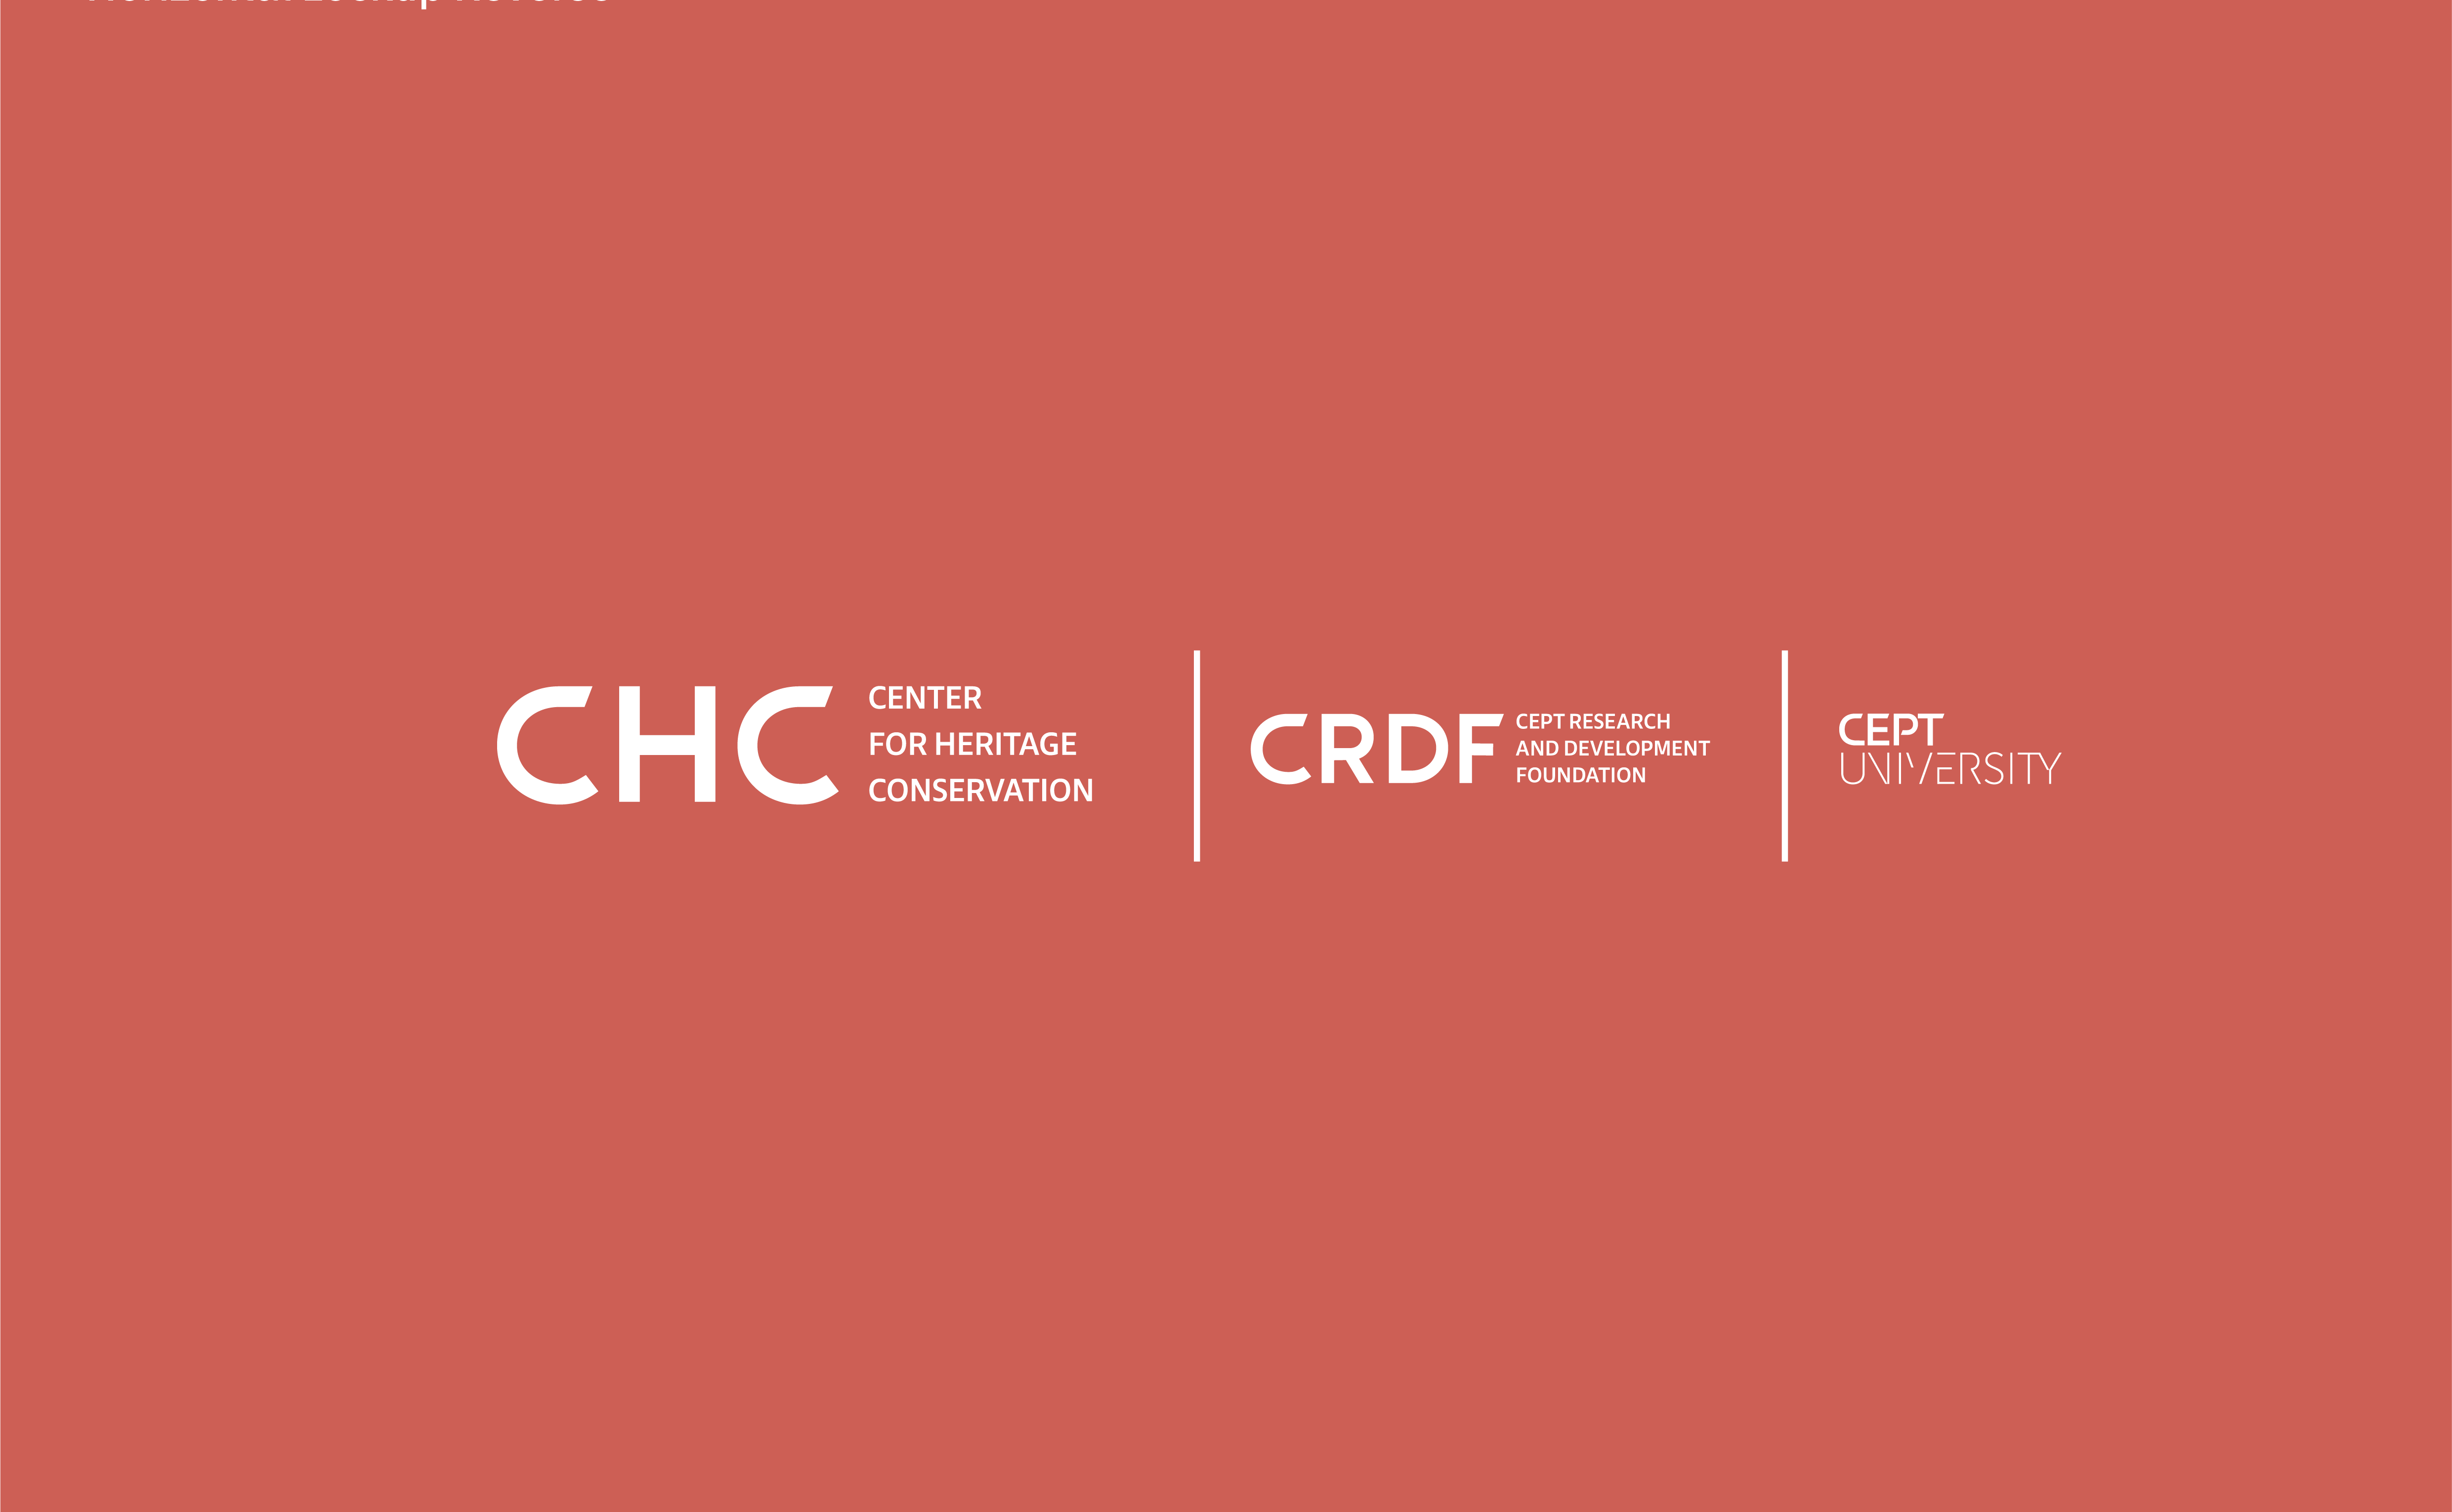
Online Certificate Course: Structural Repairs and Maintenance for Built Heritage by Center for Heritage Conservation (CHC)

Apply Now

Course Prerequisite: Participants must have a Bachelor's degree in Civil Engineering, Architecture, and any field allied to applied mechanics studies. A resume/CV would be part of the registration process.

Course Fee: Rs 22,000 / $ 300 per student.

Seats: 25

Alternatively, participants can download the form and email it with the required documents at chc@cept.ac.in. Add “Application for Online Course on Structural Repairs and Maintenance for Built Heritage” in the Subject line.

Selected candidates will be notified by email and will complete the registration process through the CRDF website.

First Name*

Last Name*

Date of Birth*
Month, Day, Year

Educational Qualification*

Mobile Number*

Email Address*

Residential Address*

City*

State*

Country*

Postal Code*

Statement of Purpose (250 words PDF format) Please attach a PDF with the form.*

Resume or CV (PDF format) Please attach a PDF with the form.*

Have you previously engaged with structural repairs for historic buildings? If yes, please write a brief note on your experience.*

